|  |  |  |
| --- | --- | --- |
| **Name** | **ID** | **STUDENT SIGN** |
| **MD FAHAD KHAN** | **20-43328-1** | **fahad** |

**Class Test 04**

1. Normalize the ER Diagram given below up to 3rd Normal Form and finalize the tables that needs to be created. Then (in Oracle using SQL) write down the queries that are required to create all the tables with necessary constraints. Also insert at least 3 rows of data in each created table.

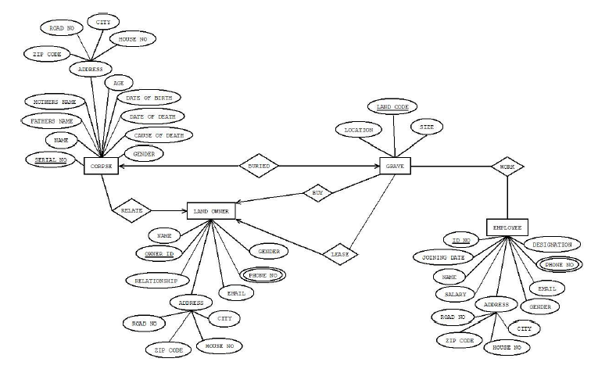

Answer Box (Normalization steps in detail as shown in Normalization Tutorial Slide + all the queries required to create the tables and insert data after Normalization):

**Normalization**

**Buy:**

{Land code, Location, size, Name, Owner id, Name, Relationship, Road no, Zip code, house no, city, email, hone no, gender}

**1NF:**

Phone no is multivalued attribute here.

(Land code, Location, size, Name, Owner id, Name, Relationship, Road no, Zip code, house no, city, email, phone no, gender)

**2NF:**

* Land code, Location, size
* Owner id, Name, Relationship, Road no, Zip code, house no, city, email, phone no, gender

**3NF:**

* Land code, Location, size
* Owner id, Name, Relationship, email, phone no, gender
* A-ID, Road no, Zip code, house no, city

**Work:**

{Land code, Location, size, Owner no, Joining date, Name, Salary, Road no, Zip code, house no, city, Gender, Email, Phone no, Designation}

**1NF:**

Phone no is multivalued attribute here.

(Land code, Location, size, Owner no, Joining date, Name, Salary, Road no, Zip code, house no, city, Gender, Email, Phone no, Designation)

**2NF:**

* Land code, Location, size
* Owner no, Joining date, Name, Salary, Road no, Zip code, house no, city, Gender, Email, Phone no, Designation.

**3NF:**

* Land code, Location, size
* Owner no, Joining date, Name, Salary, Gender, Email, Phone no, Designation.
* A-id, Road no, Zip code, house no, city.

**Buried:**

{Serial no, Father name, Mother name, Zip code, Road no, City, House no, Age, Date of birth, Date of death, Cause of death, Gender, Land Code, Size, Location}

**1NF:**

No multivalued attribute.

(Serial no, Father name, Mother name, Zip code, Road no, City, House no, Age, Date of birth, Date of death, Cause of death, Gender, Land Code, Size, Location)

**2NF:**

* Serial no, Father name, Mother name, Zip code, Road no, City, House no, Age, Date of birth, Date of death, Cause of death, Gender
* Land Code, Size, Location

**3NF:**

* Serial no, Father name, Mother name, Age, Date of birth, Date of death, Cause of death, Gender
* Land Code, Size, Location
* A-id, Zip code, Road no, City, House no

**Relate:**

{Serial no, Father name, Mother name, Zip code, Road no, City, House no, Age, Date of birth, Date of death, Cause of death, Gender, Owner id, Relationship, Road no, Zip code, house no, city, email, phone no, gender }

**1NF:**

Phone no is multivalued attribute here.

(Serial no, Father name, Mother name, Zip code, Road no, City, House no, Age, Date of birth, Date of death, Cause of death, Gender, Owner id, Relationship, Road no, Zip code, house no, city, email, phone no, gender)

**2NF:**

* Serial no, Father name, Mother name, Zip code, Road no, City, House no, Age, Date of birth, Date of death, Cause of death, Gender.
* Owner id, Relationship, Road no, Zip code, house no, city, email, phone no, gender

**3NF:**

* Serial no, Father name, Mother name, Age, Date of birth, Date of death, Cause of death, Gender.
* Owner id, Relationship, Road no, Zip code, house no, city, email, phone no, gender

**Lease:**

{Land code, Location, size, Owner id, Name, Relationship, Road no, Zip code, house no, city, email, phone no, gender}

**1NF:**

Phone no is multivalued attribute here.

(Land code, Location, size, Owner id, Name, Relationship, Road no, Zip code, house no, city, email, phone no, gender)

**2NF:**

* Land code, Location, size
* Owner id, Name, Relationship, Road no, Zip code, house no, city, email, phone no, gender

**3NF:**

* Land code, Location, size
* Owner id, Name, Relationship, email, phone no, gender
* A-id, Road no, Zip code, house no, city.

**Table creation**

Create table cordse (

Serial no number(10) primary key,

Name varchar(20),

Fathers name varchar(20),

Mothers name varchar (20),

Age number (10),

Date of birth date,

Date of death date,

Cause of death varchar (100),

Gender varchar (10)

);

**Table creation**

**Cordse table:**

Create table cordse (

Serial no number(10) primary key,

Name varchar(20),

Fathers name varchar(20),

Mothers name varchar (20),

Age number (10),

Date of birth date,

Date of death date,

Cause of death varchar (100),

Gender varchar (10)

);

insert into cordse (serial_no,name,Fathers_name,Mothers_name,Age,Date_of_birth,Date_of_death,Cause_of_death,Gender)

values

(1,"X","A","B",20,20-3-2020,10-4-2020,"XYZ","male"),

(2,"Y","C","D",20,20-3-2020,10-4-2020,"XYZ","female");

**Address Table**

Create table address (

Zip_code number(10),

Road_no number (10),

City varchar (20),

House_no number (10) )

Insert into address (Zip_code,Road_no,City,House_no)

Values

(123,34,”dhaka”,33)

(122,44,”syhlet”55)

**Table creation**

**Employee table:**

create table employee (

id_no number(10) primary key,

joining_date date,

name varchar(20),

salary number(10),

designetion varchar(20),

phone_no number(20),

email varchar(20),

gender varchar(10),

address varchar (20) ;

insert into employee(id_no,joining_date,name,salary,designetion,phone_no, email,gender,address)

values

(1,"3-5-2-2011","A"45500,"ABC",12323,"abc@gmail","male","dhaka"),

(2,"3-5-2-2011","A"45500,"ABC",12323,"abc@gmail","male","dhaka");

**Land owner table**

create table land_owner(

name varchar(20),

gender varchar(10),

owner_id number(10) primary key,

email varchar(20),

phone_no number(10),

relationship varchar(20),

address varchar(20));

insert into land_owner(name,gender,owner_id,phone_no,relationship,address)

values

("abc","male",1,"abc@gmail.com",100323,"abcd","Barishal"),

("abc","male",2,"abc@gmail.com",100323,"abcd","Barishal");

**Table creation**

**Grave table**

create table grave (

location varchar(20) primary key,

land_code number(10),

size number(10),

)

insert into (location ,land_code,size)

values

("abc",143,222),

("abcddd",153,242);